

Grades 6–8 Science with Engineering Education (SEEd) Practice Clusters
We are proud to announce the inclusion of practice clusters for the new SEEd standards on the SAGE Portal. The clusters are available at the SAGE Training Test Site located online at sageportal.org
We encourage all grade 6 – 8 teachers to share the clusters with their students.
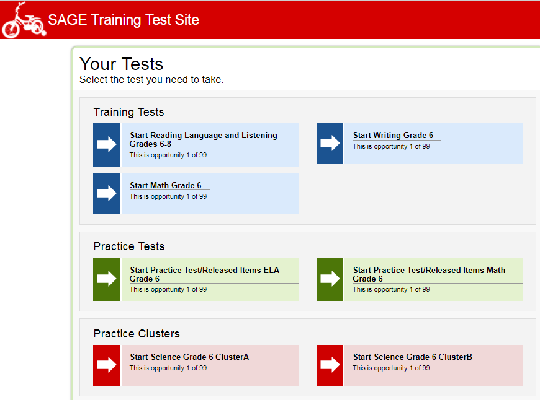
We are using clusters to assess the new science standards on the SAGE platform. You may ask, why clusters or what is a cluster? Clusters are the best way we have found to assess the three dimensions of science on a computer platform. With the clusters, students will engage in novel phenomena using the Science and Engineering Practices (SEPs) along with the crosscutting concepts (CCCs). They will have to use these dimensions to make sense of the Disciplinary Core Ideas (DCIs) around which the clusters are designed.
Clusters have some unique formats that are different from individual items or questions. Most of the time, the left side of the screen will contain a section that we refer to as the stimulus. The stimulus contains a phenomenon, an engaging story containing information that the student will use to answer the questions, and a task statement that specifically tells the student what they need to do to respond to the questions. Any task that the student performs on or in the stimulus will not be scored. Why will the stimulus appear on the left side of the screen most of the time, but not all of the time? Sometimes the information on the half screen is too big and we need to use streamline mode to have it all fit on a full screen. In streamline mode, the stimulus will be at the top of the screen, with the questions located just below the task statement. For students with vision impairments, streamline mode can be turned on for all clusters so that a screen reader can correctly read the cluster for that student.
The right side of the screen will contain a list of questions or items that the student must answer in order to receive points. Most of the item types that we have historically used in Utah will appear in this part of the cluster. There will also be item types that that are new for science teachers. For example, because one of the SEPs is “using mathematics and computational thinking,” some of the math item types have been utilized. Within all of the items, we will assess all three dimensions of a specific SEEd standard. As always, students may go back and change answers on the test at any time before they fully submit the test.
Scoring of the items is accomplished through scoring assertions. On the practice test, you can view the scoring assertions after a student has answered the questions. In the upper right corner of the item list is a small set of three (3) vertical lines.
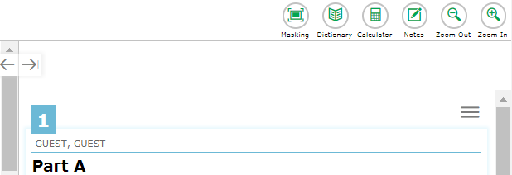
When you click on the vertical lines, a window will open with options like, “Speak Question,” “Highlight Selection,” and “Score Item.”
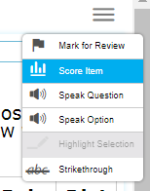
If you select, “Score Item” the program will open a pop-up window with the scoring assertions. If a student has answered a question correctly, the scoring assertion will have a green check mark in it. If the student responded incorrectly, the scoring assertion will have a red X. Each scoring assertion details a specific task that the student needed to do to get one point. As we have developed the clusters, the Utah teachers/writers have specified the required scoring assertions for the cluster. The general rule of thumb is that each time a student correctly completes one cognitive task, the student receives one point. The end-of-year summative test will not permit teachers or students to see the scoring assertions for individual clusters, but it will be graded using them.
Once a student has completed a practice cluster, they have to submit it. Once it is submitted, the student will be shown a screen where they can see their score. If the student is interested in more detail, they can click on the score and the system will take them back to the cluster and show them their answers. Because the practice cluster has been submitted, the student is not permitted to change their answers, but the student can see where they may have made a mistake. This provides an opportunity for a one-on-one discussion between the teacher and the student to examine why the student responded incorrectly and what to look for in the future to avoid making the same mistake.
We hope that you share this information with your students. Feel free to show students from your class clusters from the other grades. We do stress that you should never use these clusters to assign a score or a grade to a student. These are for practice only, not for course grades. Feel free to share them with other teachers, parents, administrators, etc. They are published for anyone to see and use. We want teachers and students to engage with them now, so that there will be no surprises at the end of the school year when the summative test is delivered.
If you are interested in keeping up to date on SEEd cluster development, please sign up for the listserv located at:
https://lists.uen.org/mailman/listinfo/utahscienceclusterdevelopment
You can see other sample clusters by coping and pasting this link into your browser:
https://login11.cloud1.tds.airast.org/student/V208/Pages/LoginShell.aspx?c=AIRScience&v=208
If you have questions about the new clusters, please contact me at: scott.roskelley@schools.utah.gov

Please note that the practice and sample clusters were created for use in Utah and other states. The sample clusters may not align to specific grades or Utah standards. The practice clusters were specifically selected because they do align to Utah standards. The purpose of the practice and sample clusters is to increase familiarity with the clusters among students and teachers.

